

MITR Team 5: Zoha Ahmed, Harish Arul,

Aditya Borkar, Edward Lee, Catherine Williams

**Table of Contents**

**Executive Summary 2**

**Introduction 4**

**Client Organization and Description 4**

**Project Team 5**

**Problem Statement 6**

**IS/IT Solution Scope 6**

**Methodology 7**

**IS/IT Requirements 8**

**IS/IT Design 10**

**Cost-Benefit Analysis and Risk Management 19**

**Project Management 24**

**Post Turnover Plan 28**

**Results and Feedback 29**

**Conclusion 30**

# 

# **Executive Summary**

Recognizing the lack of Korean cuisine in the Troy, NY area, K-Plate aimed to enter this underserved market. The owner, Kevin Shin, having moved to the area to attend RPI, noticed a shortage of options for the Korean dishes and flavors he grew up with. With a desire to cater to the college student population, he decided to create a Korean restaurant that would break away from the more traditional high-end, family-style barbecue and focus on the more popular and accessible street foods that would resonate with students.

The team included the following five individuals: Zoha Ahmed, Harish Arul,

Aditya Borkar, Edward Lee, and Catherine Williams. Zoha Ahmed was the data analytics lead, Harish Arul was the front-end lead, Aditya Borkar was the full stack developer and back-end co-lead, Edward Lee was the client liaison and back-end lead, and Catherine Williams was the project manager and data analytics co-lead.

Upon reviewing potential clients, the team discovered that K-Plate’s website was outdated and lacked administrative capabilities for tracking key business data. To improve customer engagement and reduce resource waste, such as unnecessary labor hours and surplus ingredients, the team developed a plan to update the current website and create an administration portal. The redesigned website would feature improved navigation, customer loyalty programs, an updated featured items section, and a more modern aesthetic. The administration portal would provide the owner and staff with access to predictive data regarding future inventory needs, ordering trends, and other key metrics. Additionally, an inventory tracking feature would be implemented, including stock notifications accessible via a separate page within the administration portal.

IS/IT functional requirements were categorized into four sections that included people, processes, user interface, and software. People, processes, and user interface sections contained the products’ functionality and look, while the software section contained the purposes of the software and where they were to be used.

IS/IT non-functional requirements were categorized into four sections that included accessibility, documentation, load-time, and scalability. Accessibility and load-time had the purpose of enhancing the user’s experience when using the applications, while documentation was to be used to assist staff and client use of the products. Scalability should decrease the need for future updates and thus costs on the products, in addition to creating ease when expanding the company.

The IS/IT design for this project consisted of two key components: a redesigned customer-facing website and a secure administrative panel. The customer website, updated through Weebly, featured a cleaner layout, improved mobile responsiveness, and a loyalty program integration that redirected users to Square for reward tracking. The admin panel was developed as a standalone Python application using PyQt5. It included secure login functionality, inventory tracking, meat usage calculations, and predictive analytics. Staff could log in, view order trends by hour and day, manage ingredients, and review projected inventory levels based on expected restocks. The system was designed to support data-driven decisions through clear visual dashboards.

A risk analysis was conducted for the project, resulting in a discount rate, or risk-adjusted interest rate, of 12%. This was applied in the cost-benefit analysis (CBA), which spanned from 2025 to 2029. The CBA yielded a net present value (NPV) of $33,804 and an internal rate of return (IRR) of 388%, reinforcing the financial viability of the project.

To manage the project, the team used Gantter software to create a Gantt chart that would serve as the project timeline. The Gantt chart outlined resource allocation, task divisions, time estimates, and dependencies between tasks, whether parallel or sequential. This led to the adoption of a hybrid Agile-Waterfall methodology, which helped keep the project on track and efficient.

A post-turnover plan was created to ensure that the product was easily and quickly adopted by staff. Additionally, the team needed to continue communicating with the client to ensure the product functioned as expected. The post-turnover plan consisted of post-implementation follow-ups, thorough documentation and user manuals, and staff training.

Throughout the planning, development, and testing phases, open communication between the team and the client was prioritized to ensure the creation of a high-quality product that met the client's expectations. This transparency allowed the client to inform the team of any software limitations, which posed minor challenges during development. However, viable solutions were found, and the project stayed on schedule.

The final product produced by the team was a success as it met client and team expectations within the given timeline. The website included both features requested by the client and features the team believed would improve user experience, while the administration page was easily implemented with minimum staff training required. For future adaptation, the owner would like to expand the variety of meats used in the meat by weight calculator.

Effective communication, time management, resource allocation, and problem-solving all played key roles in the successful completion of the project. Overall, the project met client expectations and demonstrated financial viability, making it a success.

# **Introduction**

K-Plate is a local food service provider aiming to expand its digital presence and optimize its back-office operations. The company faces challenges in digitally attracting its target audience and maintaining synchronized inventory data across both physical and online ordering channels using the Square Point of Sale (POS). Effective solutions include modernizing K-Plate’s online storefront and implementing inventory management features through an administrative page.

# **Client Organization and Description**

K-Plate is a small local business restaurant offering Korean cuisine with a casual street-food twist that caters to college students in the Troy, NY area. K-Plate’s menu consists of plates, appetizers, sides, snacks, teas and coffees, and canned beverages. K-Plate also provides a fun and inviting environment with movies projected on the walls.

Established by Rensselaer Polytechnic Institute (RPI) alumnus Kevin Shin in 2015, K-Plate began as a food truck near the RPI campus before operating at the Troy Kitchen food court. Eventually, it settled into its current location at 78 4th St, Troy, New York. Currently, K-Plate has one location in Troy, NY, with about 15 employees. Kevin's vision was to offer an accessible alternative to the high-end, family-style barbecue typically found in Korean restaurants. Realizing there was a lack of Korean food options in the Troy area, he wanted to bring the dishes and flavors from his upbringing to the local community, offering them at a price that would be affordable for college students.

The client liaison, Edward Lee, communicated primarily with the owner, Kevin Shin, through instant messaging and phone calls. The contact number used to communicate with Kevin was (518) 720-7514. During client meetings, the team met solely with Kevin Shin.

# **Project Team**

The following students at Rensselaer Polytechnic Institute were collaborating with K-Plate to enhance its website by improving operational efficiency through inventory tracking, data analytics, and customer engagement tools. Their diverse skill sets will be essential to the successful completion of the project.

Harish Arul is a Junior dual-majoring in Computer Science (CS) and Information Technology & Web Science (ITWS). He has experience in full-stack development, cloud computing, and data analytics, having worked as a Product Manager at Moonsworth. He serves as the Front-End Lead for this project.

Edward Lee is a Senior majoring in ITWS, with a focus on web development and data-driven applications. He has experience developing interactive platforms and optimizing system efficiency. His work includes leading projects that enhance user engagement and data integration. Edward Lee was the Client Liaison and Back-End Lead for this project.

Zoha Ahmed is a Junior dual-majoring in CS and ITWS, with a concentration in Machine Learning. She has experience in data engineering and AI-driven analytics. Zoha Ahmed was the Data & Analytics Lead for this project because of her expertise in data analytics and visualization.

Aditya Borkar is a Junior dual majoring in CS and ITWS, with a minor in the Cognitive Science of Artificial Intelligence. He has experience with full-stack development as well as management of a team. His skill set includes many web development stacks and frameworks, as well as a myriad of coding languages. Aditya Borkar was the Full Stack Developer and Back-End Co-lead for this project.

Catherine Williams is a Senior majoring in Chemical Engineering with a minor in ITWS. She has experience with graphic design, team management, and economic data analytics, having produced a chemical plant proposal. Catherine Williams was the Project Manager and Data & Analytics Co-lead for this project.

# **Problem Statement**

K-Plate’s current website lacks essential features to optimize operations, enhance customer experience, and support data-driven decision-making. This results in inefficiencies such as stock shortages, limited customer engagement, and missed opportunities for business insights. Although K-Plate uses Square, the owner has not yet implemented its inventory tracking features. Furthermore, he dislikes the look and feel of the software and prefers a Weebly website instead.

# **IS/IT Solution Scope**

Implementations for the improvement of K-Plate’s current website include an improved user interface, an inventory tracking service, and predictions on future costs of ingredients, projected sales, and customer preferences. The implementations were displayed on the existing website via an administration page, which would only be accessible to authorized personnel.

A modern and informative user interface is crucial for K-Plate’s marketing efforts, as it serves as the first impression potential customers have of the business. The website previously lacked product images, information on rewards and student discounts, and had an outdated, difficult-to-navigate interface. Using Weebly, an online website builder application, user experience (UX) changes such as improved hierarchy, content, usability, and user centricity were implemented. A more intuitive, informative, user-centered website will increase the likelihood of customers ordering from K-Plate both online and in person.

It is also important that an easy-to-use, visually pleasing administration page is created to cut down on the training time needed to familiarize staff with the new software. Visual representation of data analysis is crucial for an easy intake of information, along with clearly defined navigation. Well-defined notifications for stocking and a display of the most popular food items will also be posted on the administration page, so this information must be easy to find and understand.

Inventory Tracking can be used for a multitude of reasons, such as knowing when to restock, knowing which products are available or out of stock, and making sales predictions. Achieving efficiency through stock notifications can minimize the time taken to collect or check data on inventory manually. These automated notifications can also help staff determine which products may be out of stock.

Predictions of projected sales, future costs of ingredients, and customer preferences are all essential to the continuing financial success of a business. Collected data is used to determine the most popular items, ingredients needed in a week, rush hours, and much more to save money for businesses through decreased waste and labor hours. Knowing what sells best and how much of each ingredient is needed each week can reduce the waste of perishable items that may go unused, in addition to decreasing the chance of popular items going out of stock. Orders per hour, the quantity of orders that are made in every hour, can be used to determine scheduling for staff to prevent understaffing and overstaffing issues.

# **Methodology**

Due to the nature of the deliverables, it was decided that the team would complete tasks within the developmental section in parallel while completing the planning and testing phases in series. A hybrid Agile-Waterfall methodology was employed to balance the benefits of structured planning with iterative refinement. Gantter was used to create a Gantt chart and define when tasks were to be completed and specify which tasks were to be executed in either parallel or series with others. After reviewing the Gantt chart, it was clear that the use of a hybrid Agile-Waterfall methodology was required to produce a refined product within the given timeline.

A cost-benefit analysis (CBA) was also completed to determine the financial viability of the project. The net present value (NPV) and internal rate of return (IRR) were calculated to display the quantity of value the project would bring to K-Plate’s continuing financial success. The NPV was calculated with an interest rate consistent with the expected amount of risk the project would bring to the company and resulted in a positive yield, thus displaying the outweighing benefits when compared to costs.

To effectively manage the project and align with the client’s expectations, the team held biweekly meetings—one at K-Plate with the client and another on campus with just the team. During client meetings, the team reviewed the current development progress to ensure that client expectations were met or exceeded. Additionally, team meetings focused on discussing development progress, changes, challenges, and upcoming plans, fostering open communication and collaboration.

# **IS/IT Requirements**

Early on in production, a meeting was held between the team and the client to define the functional requirements for the final product. These requirements were later categorized into sections, including people, processes, user interface, and software.

## Functional Requirements:

People should be able to quickly and easily navigate to both the newer and older sections of the website and the administration page. On the administration page, the predictive data models and other graphics should be visually appealing, along with easy to understand via labelling and organization.

The website and administration page should include a navigation bar, a login option, a section for the most popular or featured items, and predictive data models. Users should be able to log in to their website accounts to review their reward points and track their progress toward reward milestones. Authorized users of the administration page should be able to log in to their accounts and access the relevant information. The login should restrict access to only those authorized by the owner, to ensure secure access to the administration site. The homepage should feature a section showcasing the current most popular products offered at K-Plate.

The user interface for both the modified customer-facing website and the administration website should be intuitive, visually appealing, and easy to navigate. The navigation bar should feature clearly defined labels for each link and dropdown, along with a logo that directs users back to the homepage. The visuals should be easy to understand, with captions or descriptions to provide additional context and clarify their purpose. Both websites should adopt a modern look to attract users and enhance the business's appeal.

Weebly, an online website builder, will be used for modifying the pre-existing website. The administration website will leverage the Square API, along with front-end and back-end development, Python programming, and. The Square API enables access to Point of Sale (POS) system data, which will power the inventory tracking system and predictive data software. These data-driven features will be converted into visual formats for easy understanding with Python and used to generate predictions and display them as user-friendly visuals on the front-end.

## Non-Functional Requirements:

* Hardware
  + The administrative panel runs locally as a Python desktop application on K-Plate’s in-store devices. No dedicated server or cloud infrastructure is required for the backend. The only hardware requirement is a standard Windows or macOS machine capable of running Python applications, with at least 4 GB of RAM and 2 CPU cores to ensure smooth operation.
* Software
  + The admin panel is developed in Python using the PyQt5 framework and compiled into a standalone executable for ease of installation. SQLite is used for local data storage, and the Square API is leveraged to sync sales and inventory data. The customer-facing website is managed through Weebly’s web-based content management system, which requires no additional software installations.
* Scalability
  + The local application is optimized for small business operations but designed to support increased complexity over time. New menu items, meats, and prediction modules can be added without needing to modify the core structure. The system remains efficient even as more historical order data accumulates, and can be adapted for multi-location use if needed.
* Security
  + The admin panel is password-protected and limited to authorized staff. Sensitive data, such as Square API credentials, is encrypted and stored securely on the local device. The system does not transmit customer information externally beyond Square’s secure API, ensuring compliance with basic data privacy standards.
* Usage
  + The application is designed for staff with minimal technical expertise. All key functions—including inventory updates, meat usage tracking, and report generation—are accessible through an intuitive graphical interface. A brief training session and an included user manual ensure easy onboarding for future employees.
* Look/Feel
  + The admin panel features a clean, professional interface consistent with K-Plate’s modern brand. Charts and data visualizations are styled for readability, with color-coded insights and organized tabs for inventory, analytics, and rewards. The customer-facing website retains K-Plate’s branding and is mobile-friendly, with a minimalist layout for quick browsing and ordering.

# **IS/IT Design**

## User Case Diagrams:

## To ensure the K-Plate website and administration portal effectively meet the needs of their target users, several user cases were identified during the development phase. These user cases outline the primary interactions between users and the system, providing a foundation for the interface and system design that aligns with client needs and operational goals.

## 

## Figure 1: A Customer Browsing the Menu and Placing an Order

## This diagram illustrates the customer journey on the K-Plate website when browsing the menu and placing an order. The customer initiates interaction by accessing menu categories, then views item details, updates their cart, and proceeds to checkout. After checkout, the inventory is updated accordingly. The Online Ordering System includes functionality to send the order to the POS system, ensuring seamless real-time synchronization with in-store operations. This use case reflects the streamlined customer experience and backend coordination.

## 

Figure 2: Customer Logging into Account and Viewing Rewards

## This diagram outlines the reward-tracking experience for returning customers. The process begins on the K-Plate website, where the customer accesses the loyalty page and clicks the button to check their rewards. This step includes a redirection to the Square website, where the customer logs into their loyalty account and views their reward progress. The diagram uses <<include>> to show that the Square login is a necessary sub-function of reward tracking. The diagram is split between the two platforms, accurately reflecting the cross-system integration K-Plate uses for loyalty management.

Figure 3: Administrator Logging Into the Admin Panel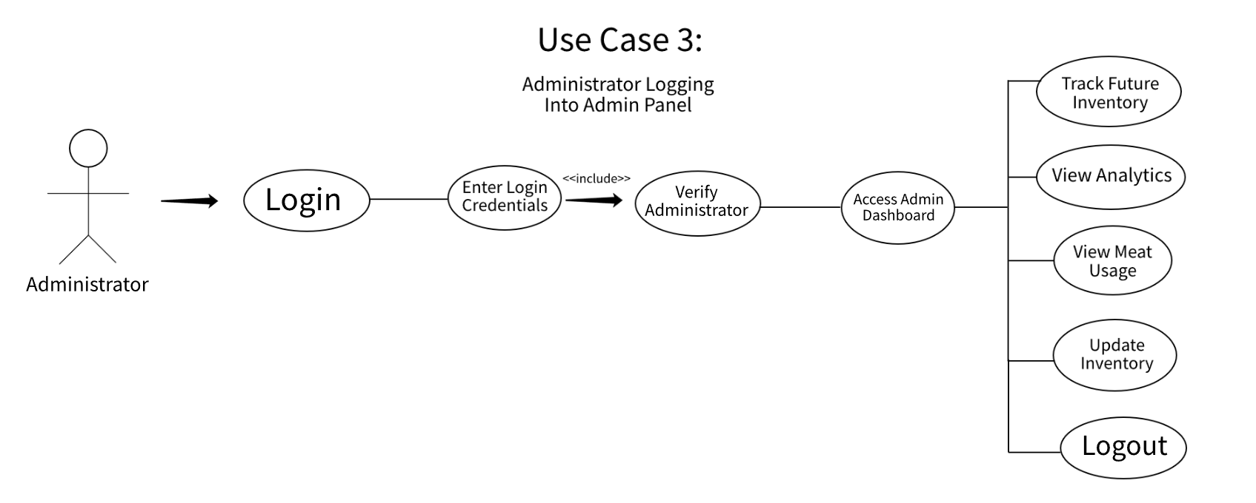

## This diagram shows the secure login process and features available to the K-Plate administrator. The admin logs in by entering credentials, which are then verified in a required (<<include>>) sub-function. Upon successful verification, the administrator accesses the Admin Dashboard, where they can perform various tasks. This use case demonstrates both the authentication flow and the range of administrative tools available within the panel.

## 

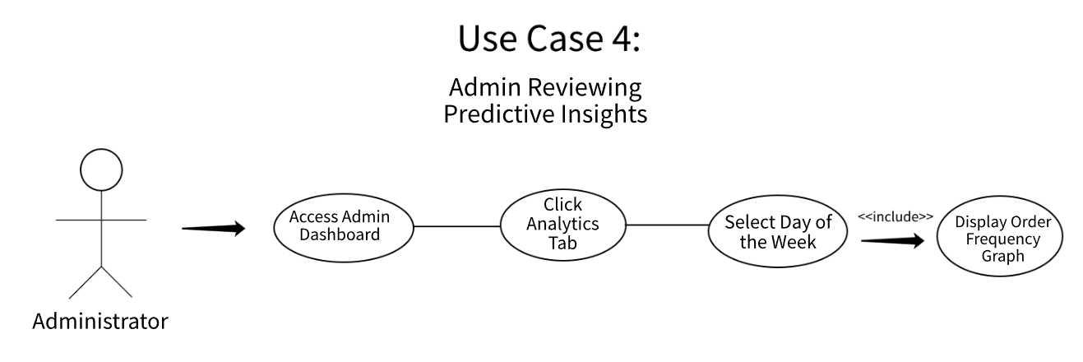

Figure 4: Admin Reviewing Predictive Insights

This use case focuses on the administrator's ability to analyze sales trends via the Analytics tab in the admin panel. Once logged in, the admin selects a specific day of the week, which triggers the display of an order frequency graph (<<include>>). This graph allows the admin to observe customer ordering patterns by hour, which supports data-driven decisions for inventory management and staffing. The diagram reflects a simple but effective flow that highlights the predictive insight functionality of the system.

## 

## 

## 

## 

## 

## 

## 

## 

## Figure 5: K-Plate Admin Panel Login Wireframe

## 

## 

## 

## 

## 

## 

## 

## 

## 

## Figure 6: K-Plate Admin Panel

## **Predictive Models:**

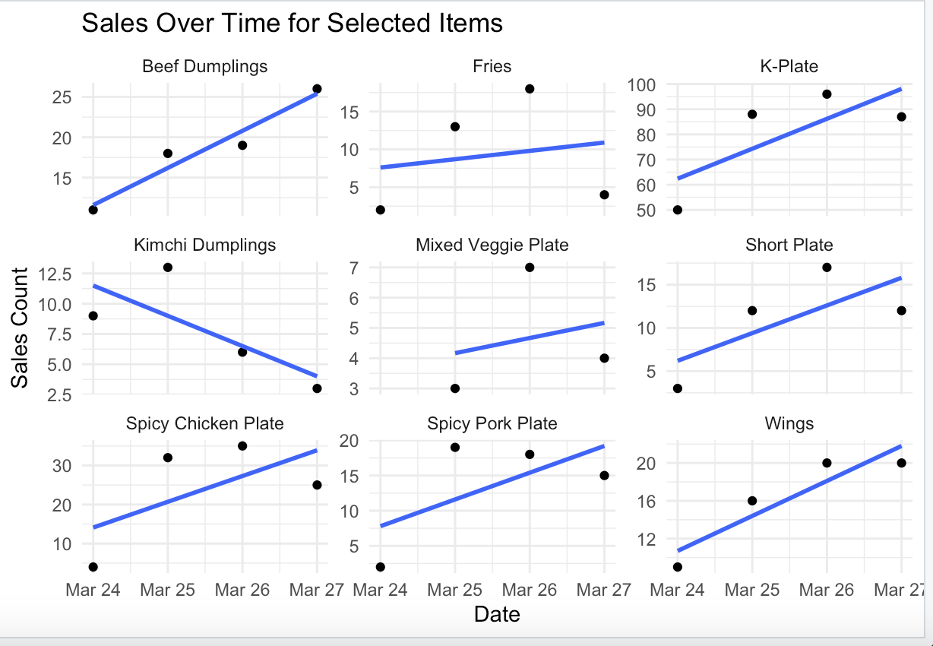

Figure 7: Sales Over Time for Selected Items

This predictive model, built in Python, shows sales trends over time for K-Plate’s most popular items. Each chart uses a linear regression line (in blue) to predict demand based on sales from March 24–27. The goal was to forecast item demand to improve inventory planning. For example, items like the K-Plate and Beef Dumplings show rising trends, while Kimchi Dumplings are declining. This helps K-Plate restock efficiently and focus on bestsellers.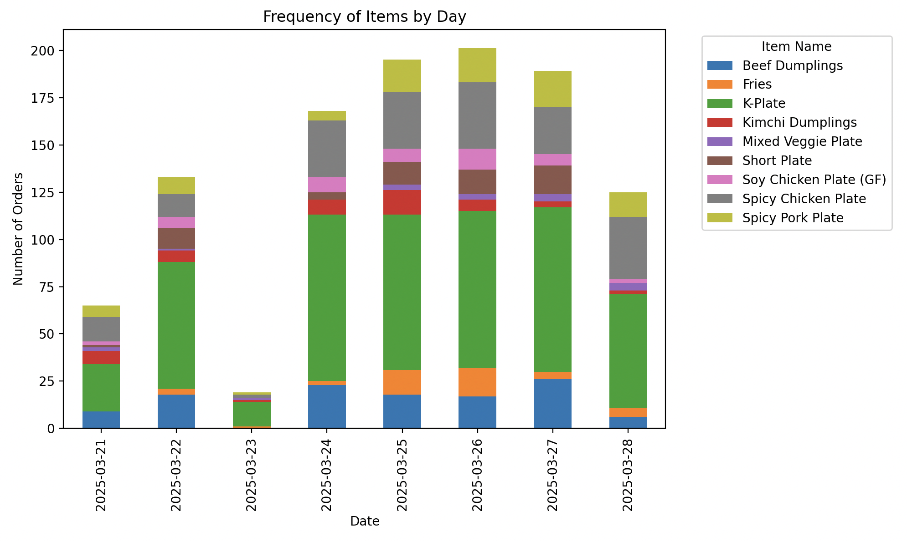

Figure 8: Frequency of Items by Day

This stacked bar chart shows how often each menu item was ordered by day. It was created to visualize daily item popularity and identify peak sales days. The K-Plate (in green) consistently had the highest demand, while items like Kimchi Dumplings and the Mixed Veggie Plate had lower but steady orders. This helps K-Plate plan staffing, prep, and promotions around high-volume days.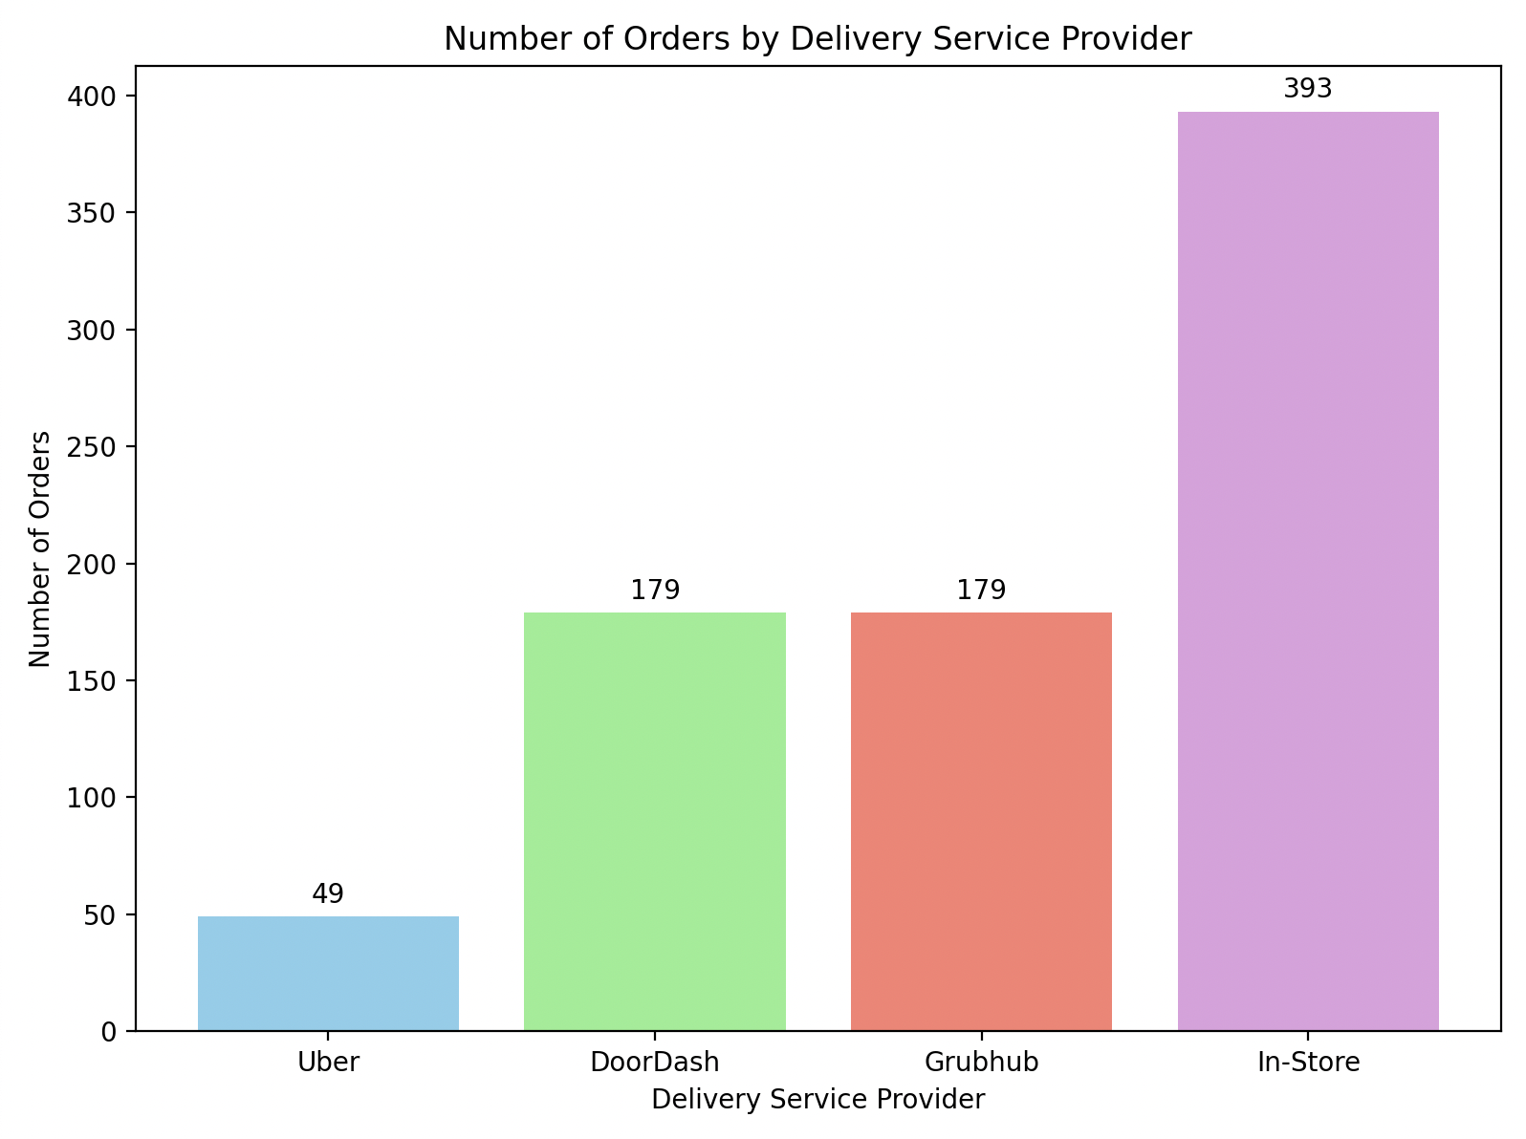

Figure 9: Number of Orders by Delivery Service Provider

This bar chart shows the number of orders by delivery service. In-store orders dominated with 393, while DoorDash and Grubhub tied at 179. Uber had the fewest at 49. This helps K-Plate understand customer preferences and where to focus marketing or delivery improvements.

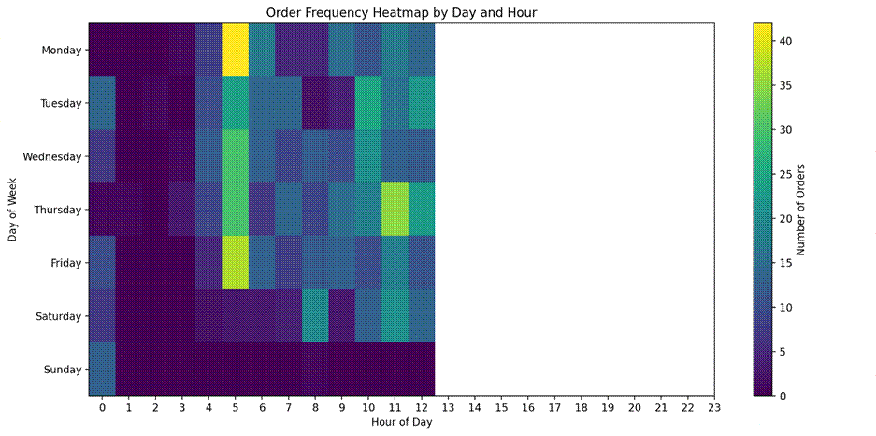

Figure 10: Order Frequency Heatmap by Day and Hour

This heatmap shows when orders are most frequent by day and hour. Most activity happens between 6 AM and 12 PM, especially on Mondays and Thursdays. This helps K-Plate staff plan better for peak hours and adjust prep times accordingly.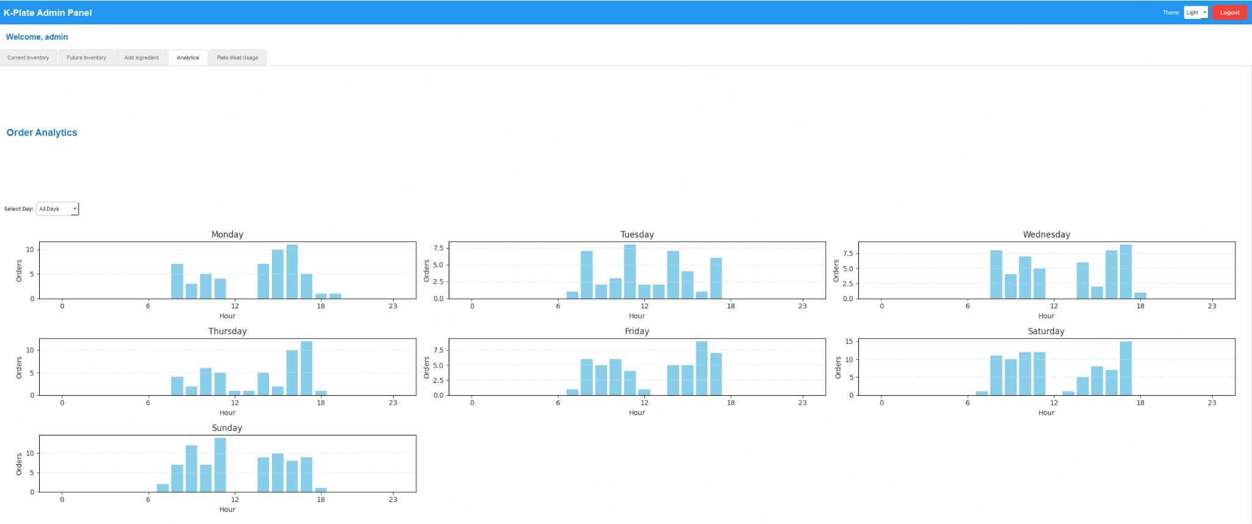

Figure 11: K-Plate Admin Panel Analytics Page

This view from the K-Plate Admin Panel breaks down order volume by hour for each day of the week. It shows that orders are busiest from morning to early evening, with Saturday and Sunday having the highest overall activity. This helps the team staff smarter and prep food more efficiently based on real demand patterns.

**Weebly Front-End**

The front-end of K-Plate’s website, built using Weebly, showcases a modern, minimalist design tailored to its primary audience—college students and young professionals in the Troy, NY area seeking Korean street food. The development team utilized Weebly’s drag-and-drop builder to reorganize the site’s content, enhance mobile responsiveness, and improve overall usability, all while staying true to the client’s branding and aesthetic preferences.

The redesigned homepage (Figure 12) prominently features a call-to-action for placing online orders, complemented by clean white space and visually striking images of food that immediately capture the user's attention. The header section includes a fixed navigation bar with links to key pages, such as “Order Now,” “Catering,” “Info,” “Apply,” and “Gift Cards.” This layout allows for smooth and intuitive browsing, with consistent links across the site to ensure easy access to important content from any page.

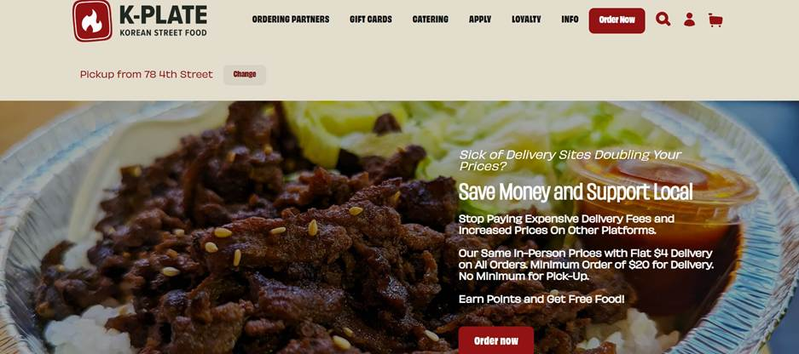

Figure 12: Final Website Homepage

The enhanced user interface emphasizes visual hierarchy and accessibility. High-resolution product images and streamlined menu categories guide users toward their desired selections efficiently. The featured items section (Figure 13) highlights K-Plate’s most popular dishes, attracting new users while providing returning customers with quick access to their favorites.

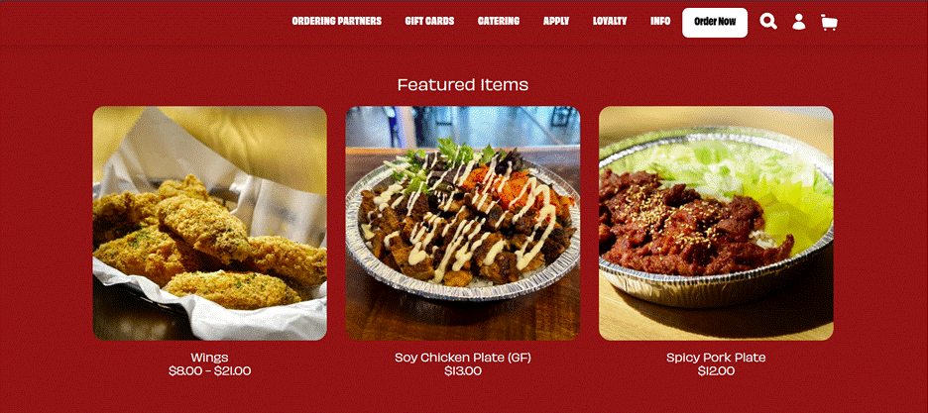

Figure 13: Website Display of Most Popular Items

Another key upgrade is the customer login functionality (Figure 14), which allows users to create and manage accounts. This section enables access to loyalty points, order history, and rewards progress. The integration of these features directly supports customer retention and incentivizes repeat purchases through gamified reward tracking.

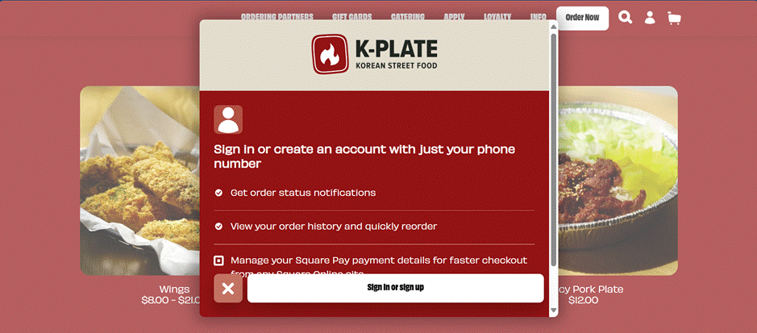

Figure 14: Customer Accounts

These updates significantly enhance the digital presence of K-Plate, presenting the restaurant as a tech-savvy, community-oriented business. The intuitive layout, refined aesthetic, and clear site structure improve first impressions and encourage continued engagement. While Weebly’s platform has limitations with advanced customization and third-party integrations, the development team implemented effective workarounds, such as linking to an external admin portal, to retain core functionality without sacrificing usability.

By balancing design simplicity with practical functionality, the new Weebly-based front-end elevates K-Plate’s branding and streamlines the customer journey from discovery to checkout.

# **Cost-Benefit Analysis and Risk Management**

A risk analysis was completed in the early stages of production to determine the discount rate needed for a cost-benefit analysis (CBA) to be done. The resulting CBA possessed a positive net present value (NPV) and internal rate of return (IRR), thus allowing the team to begin production knowing the project would yield a promising financial return.

## **Risk Analysis**

Potential risks included in the analysis were timeline delays, Square application programming interface (API) integration issues, limited client engagement or feedback, inaccurate inventory tracking, Weebly limitations, vulnerabilities with data security, poor user adoption, budget overruns, incomplete, missing, or inaccurate sales data, and hosting or server downtime. An Excel spreadsheet was utilized to display the potential risks and their corresponding impacts in dollar amounts and probabilities as percentages. Impacts were determined by assessing the resulting time delay and potential costs. A score ranging between zero and three was then calculated for each potential risk based on its respective impact and probability values. The weight of risk was then calculated based on the impact against the total combined impacts to determine the weight of each event occurring. Weights were multiplied by their respective scores and a coefficient of 3.33 to determine the weighted score of each potential risk. Using a risk-index-to-discount-rate converter chart and the combined values of each weighted risk, the associated discount rate was determined to be 12%. The discount rate was later used in the CBA as the risk-adjusted interest rate to calculate an accurate NPV.

Out of the ten potential risks analyzed, only three posed significant consequences, based on the risk analysis weighted scores. Square API integration issues, Weebly limitations, and vulnerabilities within data security had notably higher weighted scores than the rest, as a good portion of development was reliant on them. Additionally, security issues, when dealing with sensitive data, can cause a multitude of other issues for a company’s image and continuation.

## **Square Integration Issues**

Square API integration issues pose significant implementation challenges for K-Plate's inventory tracking and predictive analytics system. The primary concern involves authentication mechanisms, as the Square API requires specific credentials and tokens that must be properly maintained throughout the system's operation. These tokens may expire or become invalid if not properly refreshed, causing system downtime. Additionally, the data structure within Square's ecosystem may not align perfectly with the custom inventory tracking system being developed. Transforming and normalizing this data introduces complexity that could lead to data inconsistencies if not carefully managed.

Another potential integration issue stems from the API's rate-limiting policies. During peak business hours, K-Plate experiences high transaction volumes, and the Square API may restrict the number of requests possible within short timeframes. This could result in delayed inventory updates, precisely when real-time accuracy is most critical. The team implemented queuing mechanisms and established fallback procedures to ensure the system remained functional even during high-traffic periods.

Furthermore, as Square updates its platform, backward compatibility cannot be guaranteed. Changes to endpoint structures, response formats, or authentication requirements could disrupt the integration without notice. Establishing a robust monitoring system becomes essential to detect and address these changes promptly. Given K-Plate's reliance on accurate inventory data for both customer-facing information and back-office analytics, any prolonged API integration issues could directly impact business operations and customer satisfaction.

## **Weebly Limitations**

Weebly's limitations present several challenges to the implementation of K-Plate's enhanced website functionality and integration with inventory management systems. While Weebly offers an intuitive interface for basic website management, it restricts access to underlying code structures and databases that would facilitate seamless integration with the Square API. This limitation forced the team to develop workarounds, such as creating a separate administration website rather than embedding administrative functions directly within the main site.

The platform's restrictive JavaScript environment also posed significant constraints. Weebly implements security measures that limit the execution of custom scripts, potentially affecting the real-time display of inventory status on product pages. This limitation necessitates additional development effort to create proxy services or alternative data-fetching mechanisms that comply with Weebly's security model while still delivering timely information to customers.

Additionally, Weebly's template-based approach limits the team's ability to customize the user experience fully. While basic design elements can be modified, the underlying information architecture and user flow patterns remain somewhat rigid. This affects how efficiently users can navigate to popular items or access the loyalty program features that K-Plate wishes to highlight. These constraints necessitate careful planning to ensure that despite platform limitations, the website delivers an intuitive experience that aligns with K-Plate's vision of accessible Korean street food for the college demographic.

## **Security Vulnerabilities**

Security vulnerabilities within the K-Plate system present multifaceted risks that could significantly impact both operations and customer trust. The primary concern involves data protection, particularly since the system will process and store sensitive business intelligence such as inventory costs, sales patterns, and predictive models. Without proper encryption and access controls, this information could be compromised, giving competitors insight into K-Plate's business strategies and pricing structures. Such a breach would undermine the competitive advantage that the new system aims to create.

Authentication security also posed significant challenges, especially for the administration platform. As the system provides access to business analytics and inventory management tools, unauthorized access could lead to manipulation of stock levels, pricing information, or even fraudulent ordering. Implementing multi-factor authentication and proper session management becomes essential to mitigate these risks, but these solutions must be balanced against usability concerns to ensure staff adoption.

Customer data protection introduces additional compliance considerations. The loyalty program will collect customer contact information and purchase history, which falls under various data protection regulations. Any breaches involving this information could result in both regulatory penalties and reputational damage. Additionally, the integration between the customer-facing website and back-end systems creates potential attack vectors if not properly secured. Cross-site request forgery, SQL injection, and API exposure are particular concerns when bridging these systems. The team implemented comprehensive input validation, output encoding, and API security measures to protect against these vulnerabilities while maintaining the seamless experience that K-Plate needs to serve its college customer base effectively.

As production of the project progressed, the risks listed were monitored and mitigated as best as possible using the tactics described above. When challenges were encountered, viable solutions were able to be quickly implemented to ensure the completion of the project.

## **Cost-Benefit Analysis**

The cost-benefit analysis (CBA) spans a five-year period, from 2025 to 2029, and identifies both costs and benefits associated with the project. The largest benefit listed in the CBA is the predictive stocking capability, which generates a yearly revenue of $8,500 and a total revenue of $34,000 over the five years. This revenue was calculated using customer order frequencies for specific items each week and predictive software that estimates how many customers were unable to purchase certain items due to stock shortages. The largest cost identified is related to internet fees, totaling $840 per year and $4,200 over the five years. Internet access is essential for operating and updating the website and the administration page, and maintaining synchronization with the Square point-of-sale (POS) system and Square API.

The total benefits for the years 2025, 2026, 2027, 2028, and 2029 are as follows: $0 in 2025, $8,600 in 2026, $8,600 in 2027, $8,600 in 2028, and $8,600 in 2029. The total costs for these years are $2,590 in 2025, $1,200 in 2026, $1,200 in 2027, $1,200 in 2028, and $1,200 in 2029.

The benefits outlined in the CBA include scheduling efficiencies, proper stocking of inventory, predictive stocking benefits, and cost reduction. Scheduling efficiencies yield a yearly revenue of $2,500 and a total of $10,000 over five years. This encompasses savings from resolving over- and understaffing issues. Over-staffing results in wasted labor costs, while under-staffing leads to customer dissatisfaction due to long wait times and subpar service. These savings were calculated using predictive tools to identify and address staffing inefficiencies. Proper stocking of inventory contributes a yearly revenue of $8,500 and a total of $34,000 over five years. This benefit stems from implementing an updated inventory tracking system with built-in notifications for low stock levels. This system reduces the need for manual stock checks and prevents stockouts during busy hours. Predictive stocking benefits generate a yearly revenue of $3,600 and a total of $14,400 over five years. These benefits come from the ability to predict the required quantity of each item based on customer demand patterns, ensuring that popular items are not out of stock. This revenue was calculated using customer order frequencies and predictive software to estimate the number of customers who could not purchase certain items due to stock issues. Cost reduction contributes a yearly revenue of $360 and a total of $1,800 over five years. This benefit comes from the selling of used cooking oil to a third party, with benefit values provided by the owner.

The costs listed in the CBA include team costs, staff training, unplanned events, website maintenance fees, and internet fees. Team costs were only incurred during the first year, 2025, and thus resulted in a loss of $9,600 over the five years. This cost reflects the compensation paid to the team during production, calculated based on a 12-week period with an hourly wage of $20 per person, with each person completing eight hours of work per week (12*8*$20*5=$9600). Staff training costs were only incurred during the first year, 2025 and resulted in a total loss of $540 over the five years. This cost represents the time lost by the company for training staff on the new software, calculated for a two-hour training period with an hourly wage of $18 for each of the 15 staff members. Unplanned events or miscellaneous expenses were only incurred during the first year, 2025, and resulted in a total loss of $550 over the five years. These expenses account for any unforeseen roadblocks during the development phase. Website maintenance fees result in a yearly loss of $360 and a total loss of $1,440 over the five years. These fees cover future maintenance of the website, estimated based on anticipated ongoing needs. Internet fees result in a yearly loss of $840 and a total loss of $4,200 over the five years. These fees cover the cost of internet services required during and after the research, development, and implementation phases.

A net present value (NPV) and internal rate of return (IRR) were calculated to determine the financial feasibility of the project and were used to reinforce the product's future success. The NPV was determined to be $25,404 with an interest rate of 12%, calculated from the risk analysis, and the IRR was determined to be 99%. See Figure 15 for the full CBA.

Figure 15: K-Plate CBA

# **Project Management**

In the early stages of the project, a Gantt chart was created using a free trial of the Gantter application to define the order and timing of the sections that would need to be completed. The five main sections of the project included project initiation, project planning and research, initial implementation and draft submission, development and testing, and final refinements and presentation prep. Each section included the division of labor, timeline of completion, and predecessor for every task. Figure 16 displays images of the completed Gantt chart.

Figure 16: Gantt Project Timeline

## **Project Initiation**

Tasks within the project initiation section focused on defining a problem and solution, team and client expectations, approaches to solution completion, and determining the financial viability of the product. The tasks listed within the project initiation section spanned from January 6th, 2025, until February 9th, 2025, for a total duration of 35 days.

The main focus of the project initiation section was to collect information from the client to create a strong basis for what should be accomplished within the developmental phase. The team then met to examine the client’s expectations and devise a plan for how the project would be developed and implemented. Once the project became more well-defined, a risk analysis, cost-benefit analysis (CBA), and Gantt chart were made. A large portion of the project initiation section was completed by the project manager and client liaison, with input from the team.

## **Project Planning and Research**

The tasks in the project planning and research phase focused on determining the appropriate software, programming languages, and prediction models to use to develop a high-quality product within the designated timeframe. This phase spanned from February 9th, 2025, to February 26th, 2025, for a total duration of 17 days.

The main objective of this phase was to gain access to K-Plate’s Square point of sale (POS) system data and analyze which information would be most useful for development. The client liaison coordinated with the owner to obtain credentials for accessing K-Plate’s Square account and create an API key to retrieve the necessary data. It was also decided that the Weebly platform would be used to update the existing front-end of K-Plate’s website. Additionally, a separate website would be developed for the administration page, where prediction data and stock alerts could be monitored. Finally, it was determined that Python would be used for performing the prediction calculations as it was the most suitable programming language for this task, and it incurred no costs for the use of the software.

## **Initial Implementation and Draft Submission:**

The initial implementation and draft submission phase focused on laying the groundwork for the majority of the development work, alongside the completion of the initial report draft. This phase spanned from February 26th, 2025, to March 2nd, 2025, for a total duration of five days.

During this phase, the primary objective was to define the scope of the inventory tracking and predictive capabilities. The back-end development team examined how the POS system data was structured and how to manipulate the data to generate predictions, starting with a small sample set of data from the past week. In parallel, the front-end developers redesigned the existing K-Plate website to enhance its visual appeal and improve navigation. Work on the administration site also progressed, with the login page and overall site structure nearing completion. Additionally, the team met with the owner to receive feedback on the current deliverables, including the progress made on the predictive software.

## **Development and Testing**

The development and testing phase involved the largest amount of work and time commitment, as it encompassed the development and refinement of the most critical deliverables. The finalization of the prediction software and its associated visuals on the administration page was completed during this phase. The tasks in this section spanned from March 2nd, 2025, to April 3rd, 2025, for a total duration of 32 days.

The main focus of the development and testing phase was to develop and refine predictions related to projected sales, future ingredient costs, and customer preferences, using a large volume of historical data and regression models. During this phase, the back-end functionality for the administration page was connected, including the stock alerts and the display of predictive data visuals. The prediction software was validated through numerical methods to ensure accuracy. The data sets used for predictions were expanded to cover periods ranging from one month to two weeks before to ensure robust forecasting and to treat singular events as outliers. Integration testing, along with the testing of both back-end and front-end components, was conducted and debugged where necessary. User experience and user interface adjustments were made based on feedback from the owner and external users. Finally, the draft of the term project paper was written and submitted on April 1st, 2025, to meet the stipulated deadlines.

## **Final Refinements and Presentation Preparation:**

The final refinements and presentation preparation phase focused on perfecting the deliverables and preparing for the term project presentation. The tasks in this phase spanned from April 3rd, 2025, to April 11th, 2025, for a total duration of eight days.

The primary goal of this phase was to make final adjustments to the deliverables, ensuring they were of the highest quality and required minimal future maintenance. The inventory tracking and prediction software was optimized for improved performance and efficiency while reducing run-time. The term project presentation and final report were drafted, finalized, and submitted before April 21st, 2025, to meet stipulated deadlines~~.~~

# **Post Turnover Plan**

To minimize potential issues with the ongoing use of the product and ensure its continued success, a comprehensive post-turnover plan was developed. This plan includes post-implementation follow-ups, thorough documentation and user manuals, and staff training.

Post-implementation follow-ups and continued communication are essential to ensure that the client’s expectations have been met and that the product continues to function as intended over time. The client liaison is scheduled to meet with the client on April 24th, 2025, and May 1st, 2025, to address any implementation issues, concerns, or additional requests. Furthermore, the client is encouraged to reach out to the team if any future maintenance, adjustments, or additions are required before May 5th.

Thorough technical documentation and user manuals were created during product development and provided to the client on April 21st, 2025. The documentation includes well-commented code and details on the software used during development. Additionally, design changes and decisions are outlined in the final term project report, which the client will receive. The user manuals include step-by-step instructions for utilizing the website, such as adding members to the login system, interpreting visual data, and understanding the purpose and scope of the application.

Client and staff training were conducted upon product implementation to minimize confusion and reduce the time required for training. The client was informed on each new administrative feature, including the predictive models, stocking notifications, and website navigation. While the user interface was designed to be intuitive and easy to use, proper training is crucial to ensure that both the client and staff fully understand the system and avoid any potential confusion or misuse.

# **Results and Feedback**

A high-quality product was successfully developed and implemented within the projected timeline. The updated design of K-Plate’s website now reflects the company’s modern approach, catering to local students and the community, with a promising rewards system in place. The newly implemented administration platform has significantly enhanced the K-Plate’s capabilities by optimizing costs and providing an intuitive, user-friendly interface.

The redesigned company website features a modern aesthetic, an easy-to-navigate interface, a login feature, and a customer loyalty rewards program. These new features have greatly improved the user experience, encouraging greater customer interaction. Since the launch of the redesigned website, the number of orders, as recorded by the Square point-of-sale (POS) system, has increased.

The introduction of the administration website has led to data-driven decision-making, enabling the owner to make more informed choices regarding inventory management and staffing. The administration platform has proven to be a success, with minimal confusion during training and quick adoption by staff. The predictive features and inventory tracking capabilities have resulted in significant savings in inventory purchasing, as the frequency of out-of-stock items and product waste has decreased.

The final product was presented to the owner on March 29th, 2025, to obtain feedback on staff training and everyday use by April 5th, 2025. Feedback was given on staff training and adoption of the administration page, along with the website’s look and usability. The owner believed that the staff training sessions, carried out by the client liaison, were successful as the administration page was easy to understand and navigate. Additionally, the owner appreciated that the revamped website contained updated photos of products, a more intuitive navigation bar, a login system, and a loyalty program. The owner did express a desire to make a small change to the product by expanding the types of meat used for the meat by weight calculator, so that it included appetizer meats such as wings and dumplings.

# **Conclusion**

Key takeaways from the production of the project include the importance of effective communication with both the team and the client, proper management of time and resources, and the ability to produce a viable product.

Maintaining open communication between team members and the client is critical to the success of any project. Moving from current progress to future milestones while navigating roadblocks can be challenging. However, clear communication within the team and with the client helps to address these challenges effectively. Full transparency about current progress and the team’s capabilities ensures mutual understanding between both parties. The team was able to work together efficiently, overcome obstacles, and communicate production issues to the client, resulting in viable solutions. Ultimately, the strong communication throughout the project allowed for the successful delivery of a high-quality product that met all expectations.

Managing time and resources is closely tied to the scope of the project and the capabilities of the team. Creating a feasible scope, timeline, and budget is essential for the success of any project and forms the core of the project planning phase. The team successfully adhered to the timeline established in the planning phase, completing the scope of work within the allocated budget.

While the production of the final product did not come without challenges, the team worked diligently to find viable solutions for each issue encountered. Although unforeseen challenges are inevitable, the ability to overcome them and still deliver a product that meets the client’s expectations is paramount. The team was able to work around editing restrictions imposed by the pre-existing website, ultimately delivering the quality product promised to the client.

In future projects, the team would place more emphasis on the planning phase, as a well-thought-out plan makes development smoother and less time-consuming. More attention should have been given to the final product’s vision early on, which would have prevented some confusion during the development phase. While the team overcame these difficulties, a clearer plan could have saved valuable time and effort in production.

Overall, the production of the final product was a success, meeting all team and client expectations. The product was delivered within the specified timeline, was of high quality, and utilized resources like Weebly, as requested by the client.